**Practical no 2**

* Write a program for genrating regular expression for regular grammar.
* **Searching :**

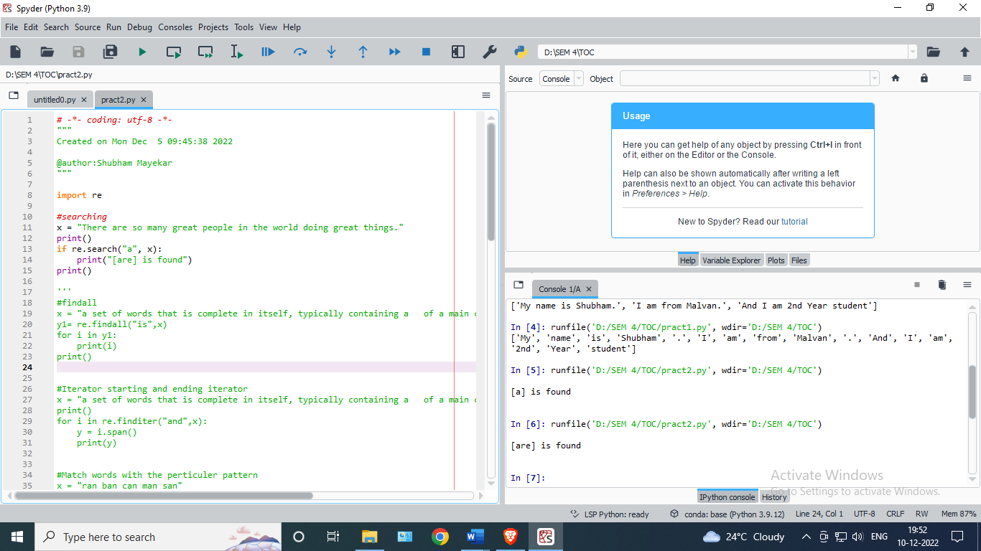

* **Output:**



* **Find All :**

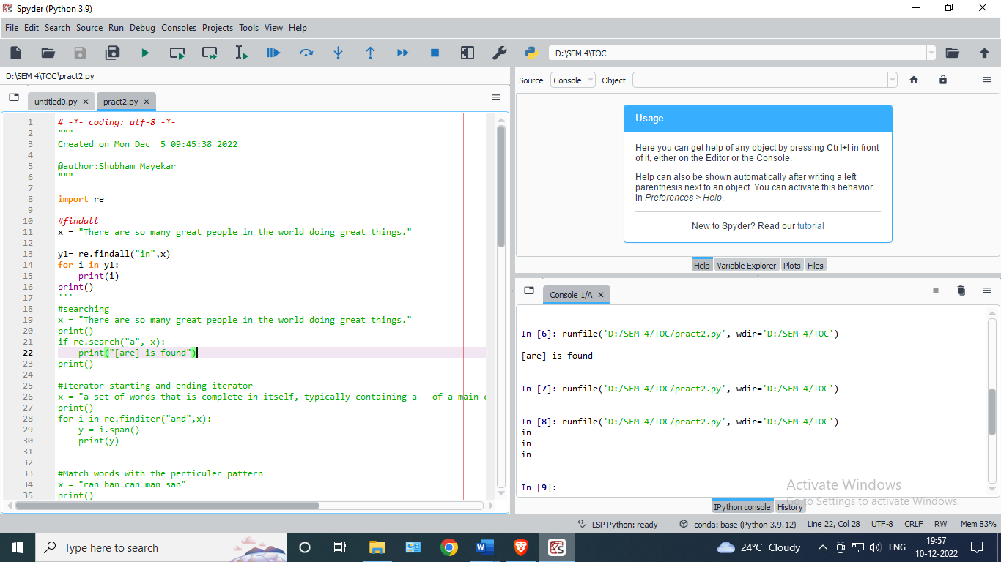

* **Output:**

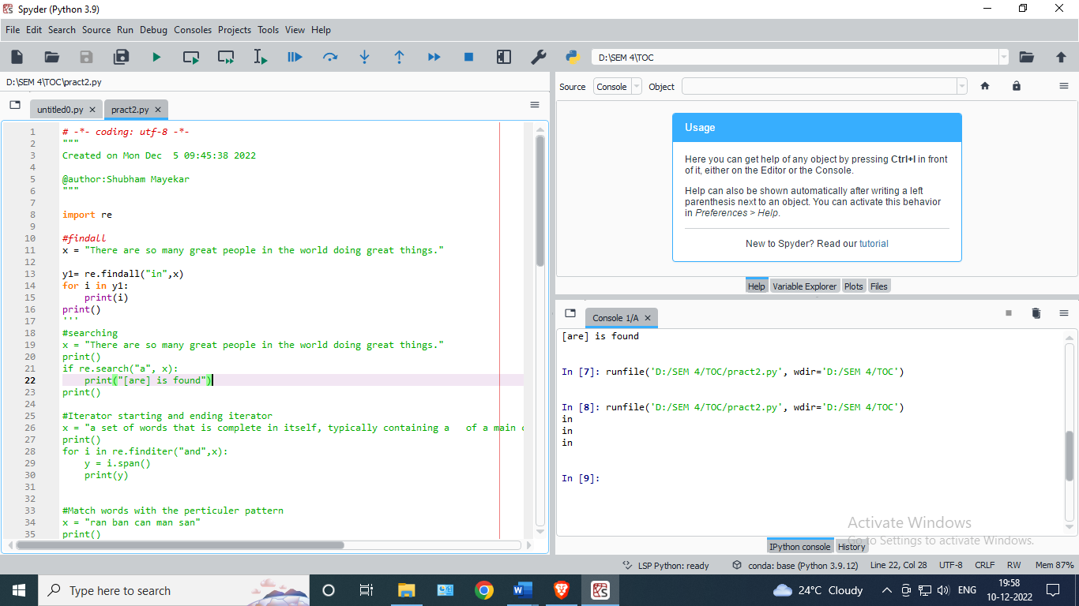

* **Iterator starting and edingiteartor :**

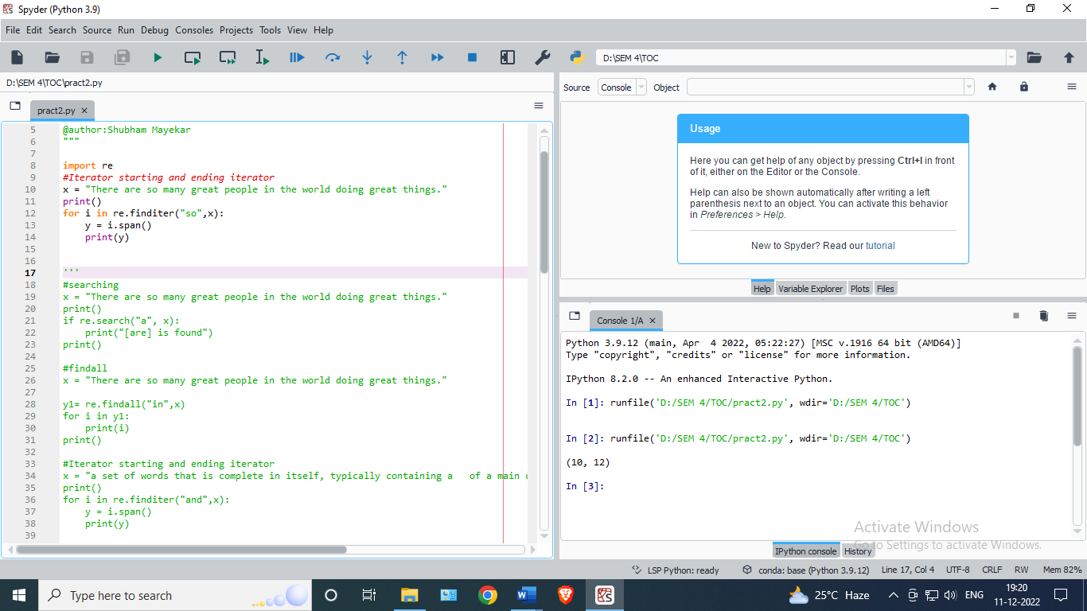

* **Output:**

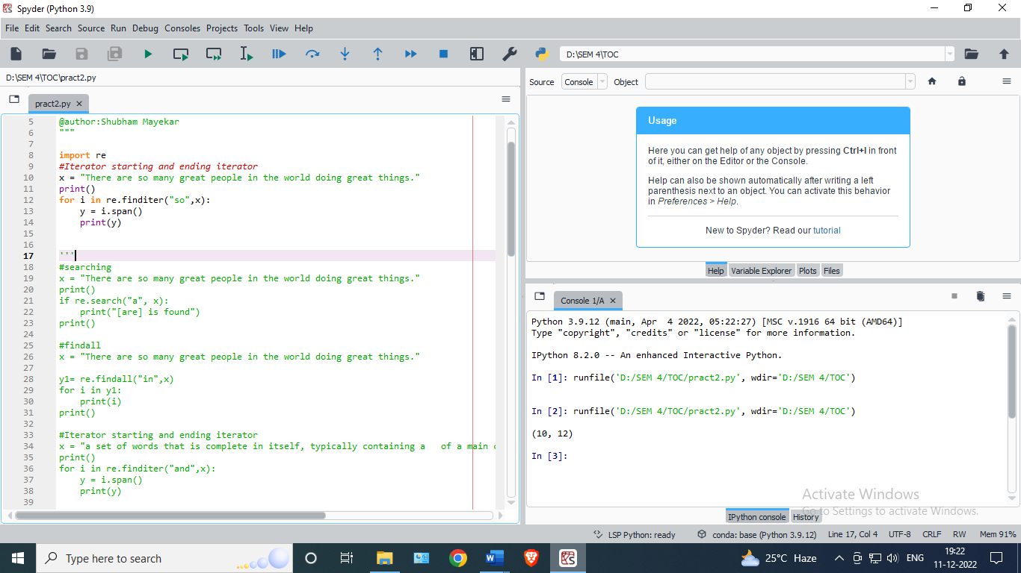

* **Match words with perticulerpattern :**

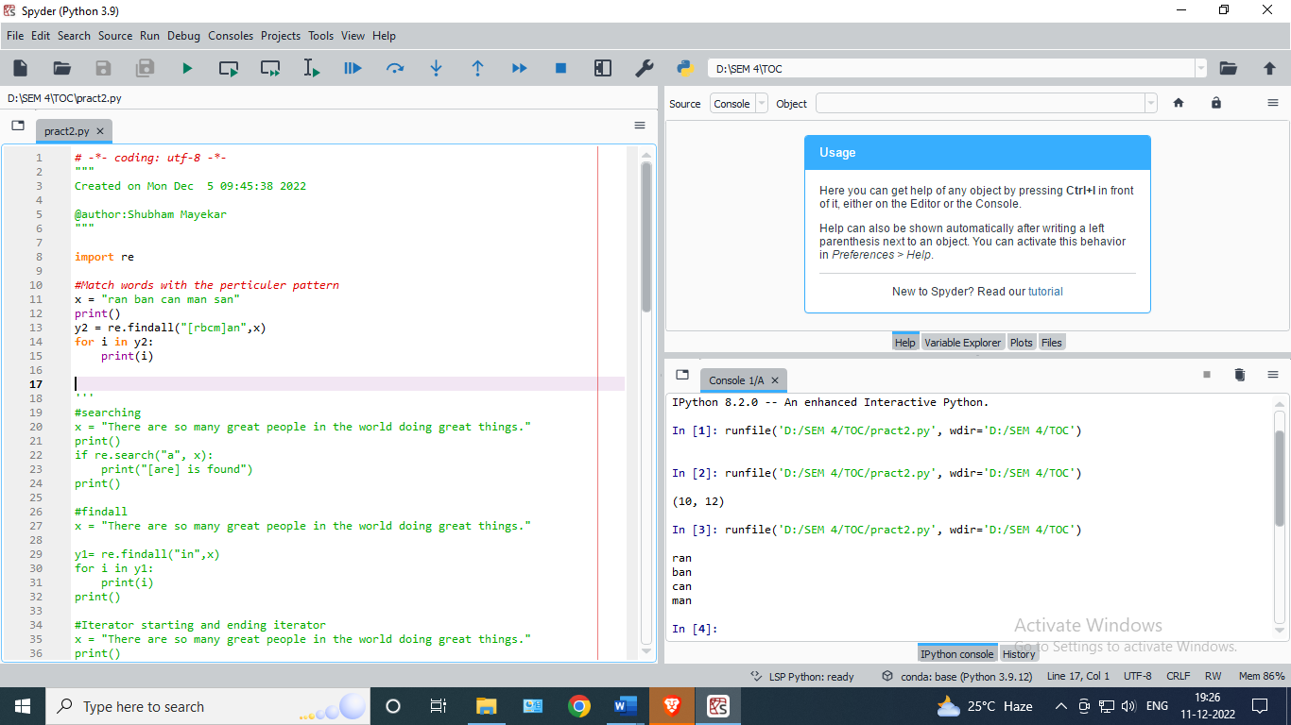

* **Output:**



* **Match series of range of character :**

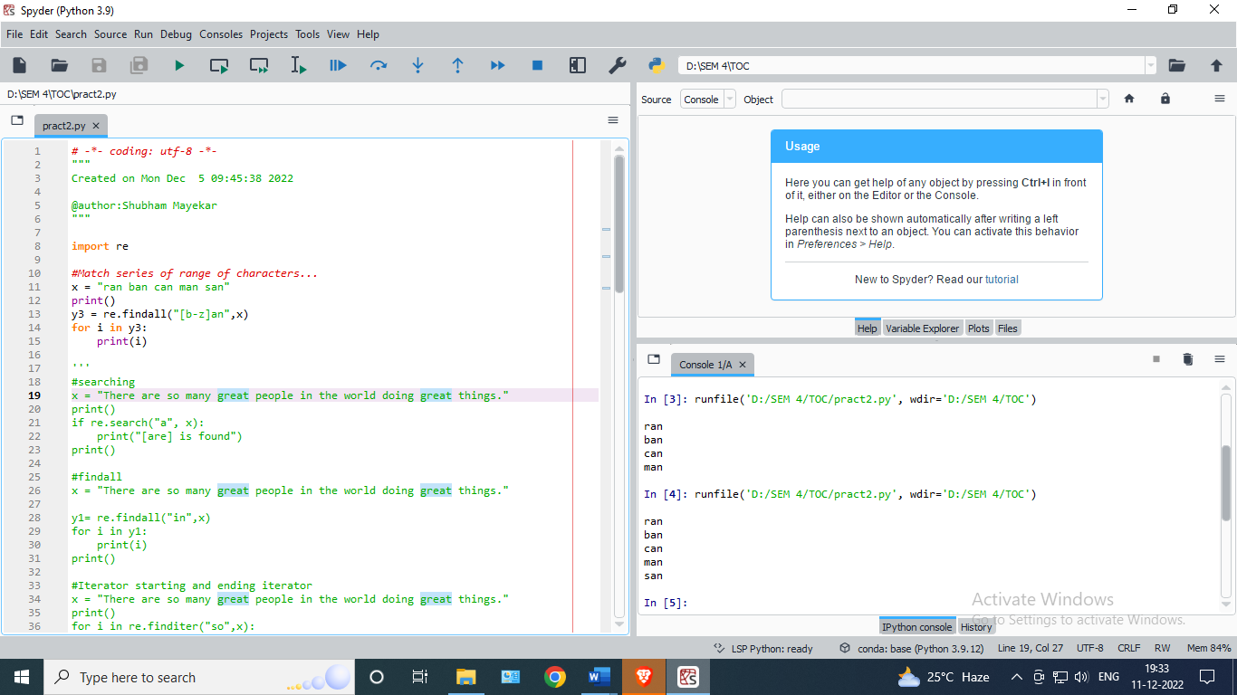

* **Output:**



* **Except the symbol:**

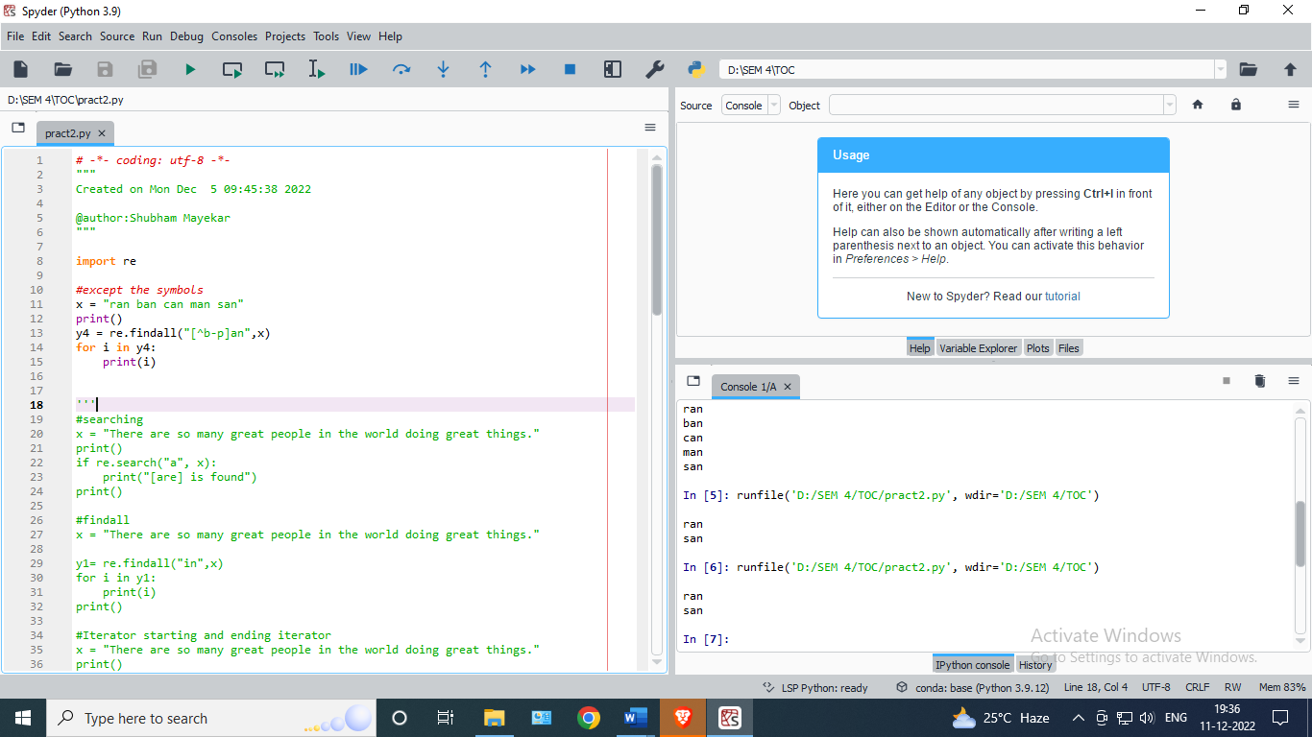

* **Output:**



* **Replace the string :**

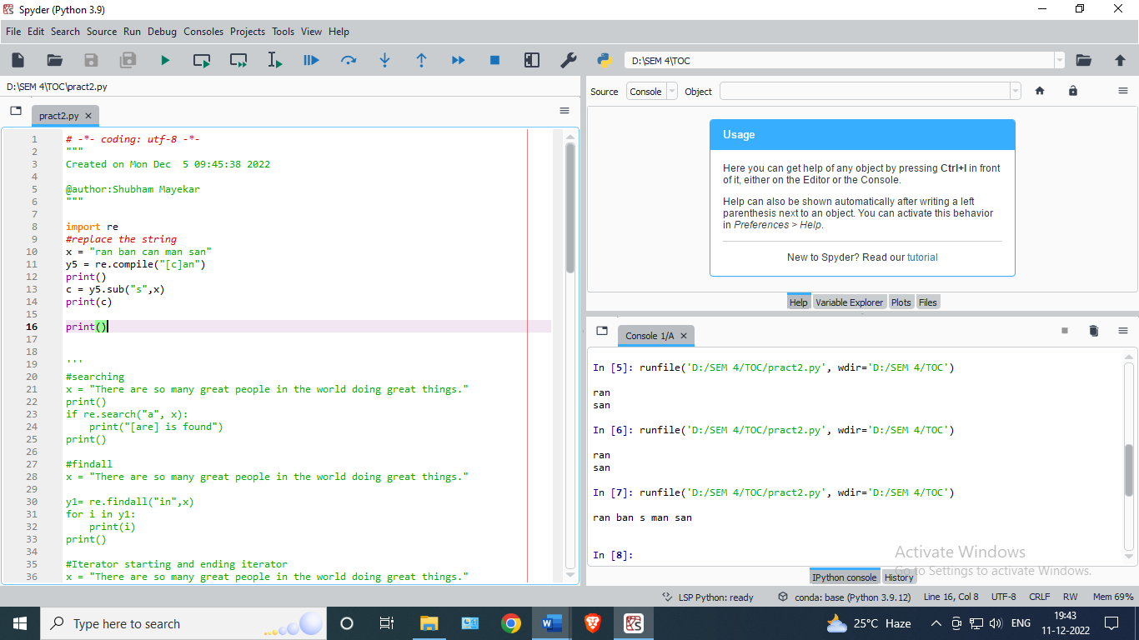

* **Output:**



* **Replace new line with space :**

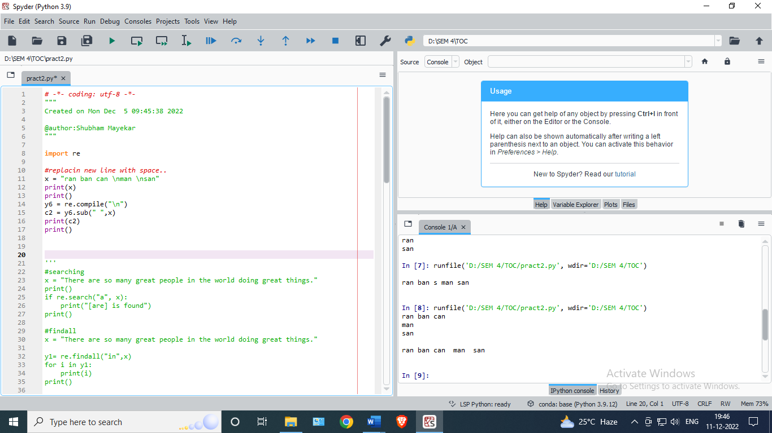

* **Output:**



* **Match character :**

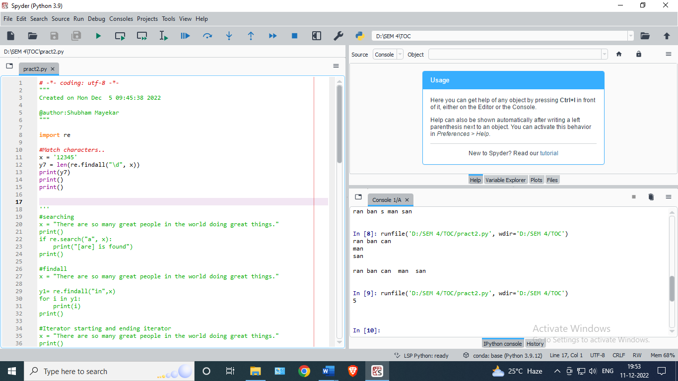

* **Output:**



* **Multiple matches :**

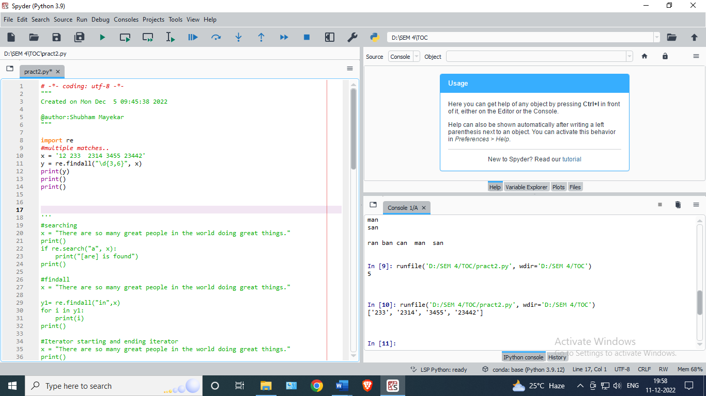

* **Output:**



* **matching 10 digit number using {\d}:**

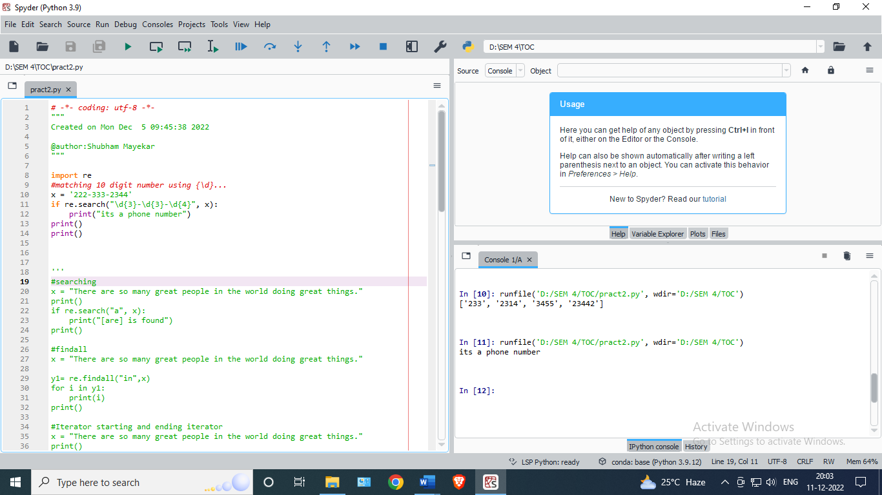

* **Output:**



* **matching 10 digit number using {\w}:**

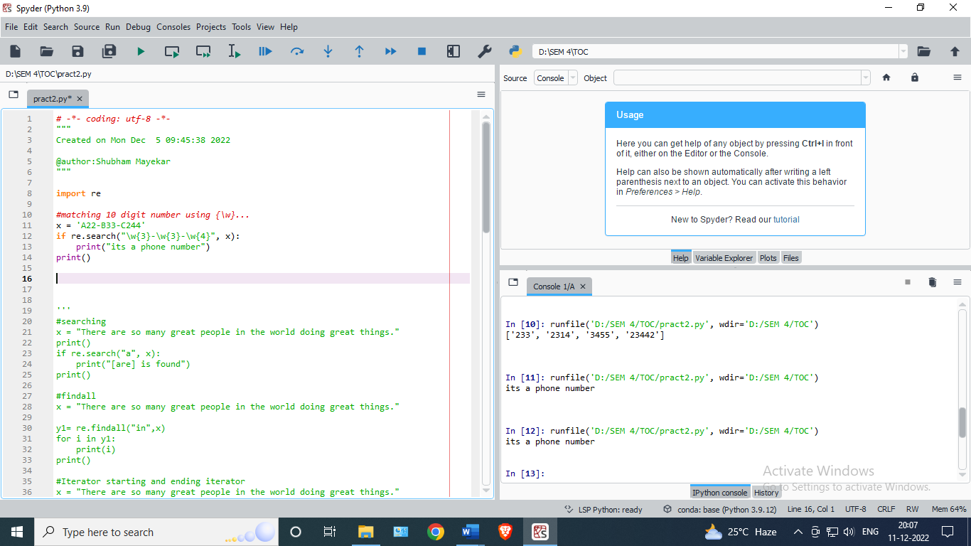

* **Output:**

